Select two questions from Question 3 through Question 6, and mark [ ] which questions you have selected on your answer sheet.
If you select three or more questions, only the first two selected questions will be graded.

Q3. Read the explanation of a procedure call below before answering Sub-Questions 1 and 2.

[Explanation of Procedure Call]
(1) There are two source programs written in a given language, Source Program 1 (Fig. 1) and Source Program 2 (Fig. 2).
① Variable “S” in the source programs is an integer-type global variable. The integer type is indicated by the “Int” keyword.
② The keyword “External” indicates an external reference. “External Int S” indicates an external reference to the integer-type global variable “S,” and “External Proc B” indicates an external reference to procedure “B.”
③ The variable “X1” is an integer-type local variable.
④ “X1 = 100” assigns the value “100” to the variable “X1.”
⑤ “Call B(X1)” calls procedure “B,” passing the variable “X1” as an actual argument. The argument is called by reference.
⑥ “Proc B(Int X2)” to “End B” indicates the range of procedure “B,” which has a formal argument “X2.”

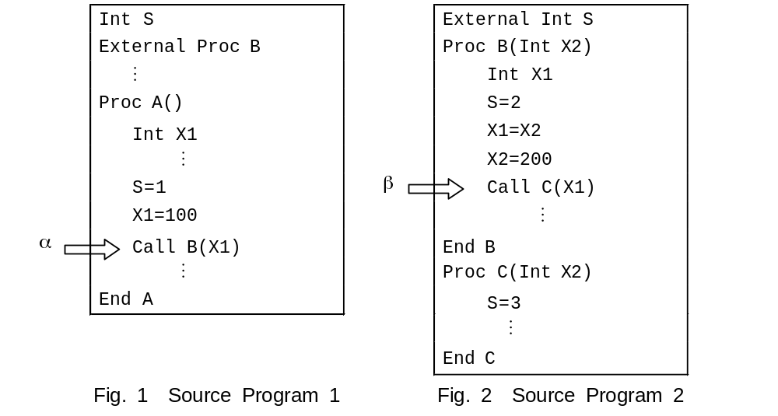

(2) Source Programs 1 and 2 are compiled and linked to create the execution file. The compiler allocates the local variables to the stack area, and the linker allocates the program code to the code area and the global variables to the data area.
(3) When the program is executed, Fig. 3 shows the contents of the stack immediately before procedure “B” is called at the location labeled α. In this example, the stack starts at the high address and runs to the low address.

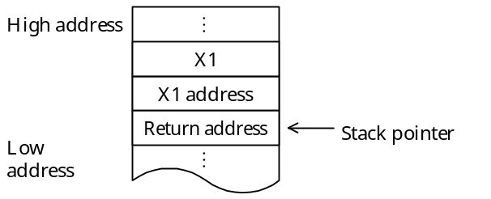
Fig. 3 Contents of Stack Immediately Before Procedure "B" Is Called

Sub-Question 1
Fig. 4 shows the contents of the stack immediately before procedure “C” is called at the location labeled β. Select the correct answers to be inserted into the corresponding boxes () in Fig. 4 from the choices provided below. Note that an address consists of one word, and an integer-type variable uses one word.

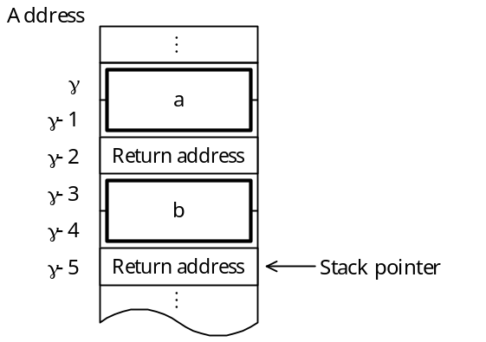
Fig. 4 Contents of Stack Immediately Before Procedure "C" Is Called

Answer group for a and b:
a) | 100 | b) | 100 | c) | 200 | d) | 200
 | γ |  | γ −3 |  | γ |  | γ −3

e) | γ | f) | γ | g) | γ −3 | h) | γ −3
 | 100 |  | 200 |  | 100 |  | 200
Sub-Question 2
Select three external references that are resolved during linking from the choices provided.

Answer group:
a) Reference to procedure “B” in procedure “A”
b) Reference to variable “X1” in procedure “A”
c) Reference to procedure “C” in procedure “B”
d) Reference to variable “S” in procedure “B”
e) Reference to variable “X1” in procedure “B”
f) Reference to variable “X2” in procedure “B”
g) Reference to variable “S” in procedure “C”

